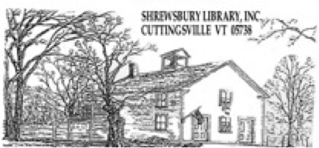
Shrewsbury Library
Meeting Room Request Form

Name of Organization:______________________________________________________________________

Purpose of Meeting:_________________________________________________________________________

Meeting Date/Time: _________________Expected Attendance: ____________________________________

Name of Representative: ____________________________________________________________________

Address: ______________________________________________________________________________________

Phone: ___________________________ Email Address:__________________________________________

Alternate Contact Name: _______________________________ Alternate’s Phone: _______________________________________

Alternate Email Address: __________________________________________________________________________________________

Usage of the meeting room must meet all of the following:

¨ We are a not for profit organization. ¨ We will not charge for this meeting.

¨ Our meeting/program is non-commercial: no solicitations, sales, or money-raising.

My signature below indicates that I agree to ensure that my organization will abide by the policies of the library with regard to meeting room use. I have received a copy of the “Shrewsbury Library Meeting Room Policies”.

• All activities held in the Library's meeting rooms must be free of charge and open to everyone. Library needs may preempt any other scheduled event.

• Commercial uses of meeting rooms are prohibited; this includes solicitations, admission or other charges, money-raising activities, and/or sales.

• Permission to use Library meeting rooms may be withheld from groups that have failed to comply with the Meeting Room Policy and from any group that damages the room, carpet, equipment, or furniture, or causes a disturbance.

- The Library does not provide refreshment supplies such as cups, plates, trays, containers, paper goods, tea and coffee.

- The Library does not provide easels, newsprint paper, dry-erase markers, or other consumable presentation materials.

- Signs and posters may not be placed on Library walls, windows or doors. Please bring your own display stands or tripods.

• All trash resulting from the serving of refreshments must be removed by the organization.

• Smoking, alcoholic beverages, open flames, burning incense, and lit candles are not allowed.

• The information listed above will be available to anyone who requests information about your group.

- Persons reserving the meeting room must be at least eighteen years of age.

If the Library is not open at the time of your meeting, a key will be available for the representative to pick up the day before or day of the meeting. Please drop the key in the book return box on the porch after you have locked the door.

Signature: _________________________________________________________ Date: ______________________________

Liability Waiver/Indemnification Agreement

I have received, read, understood, and agree to comply with the Shrewsbury Library’s
Meeting Room Policy.

I hereby fully release and discharge the Shrewsbury Library Board, from any and all claims from injuries, including death, damages or loss, which may arise or which may be alleged to have arisen out of, or in connection with the above meeting(s) in the Shrewsbury Library.

I further agree to indemnify and hold harmless and defend the Shrewsbury Library Board, from any and all claims resulting from injuries, including death, damages and losses, including, but not limited to the general public, which may arise or may be alleged to have arisen out of, or in connection with the above meeting(s) in the Shrewsbury Public Library.

____________________________________________________________________Date: __________________________________

Signature

